

DLD Lab-12
FlipFlops


NATIONAL UNIVERSTIY OF COMPUTER AND EMERGING SCIENCES, FAST- Peshawar Campus
Department Of Computer Science
EL1005 – Digital Logic Design-Lab
SEMESTER SPRING 2025

Contents
1. Objectives: 2
2. Equipment Required: 2
3. Description: 2
Flip Flops 2
4. JK- FLIP FLOP 3
5. T- FLIP FLOP 4

Objectives:
- Getting familiar with characteristic tables and characteristic functions of flip-flops
- Gaining a close insight into the functioning and properties of basic static memory circuits
- Developing skills in the composition and testing of sequential logic circuits

Equipment Required:
- DEV-2765E Trainer Board/ Multisim 14.2 /Logic.ly
- 7486 XOR Gate IC
- 7408 AND Gate IC
- 7432 OR Gate IC
- 7404 Inverter Gate IC
- 7474 Dual +ve edge triggered D-Flip Flop
- 74112 Dual –ve edge triggered JK-Flip Flop

Description:

Flip Flops
A flip-flop is usually constructed by combining two same or different types of latches. Flip-flop circuits are constructed in such a way as to make them operate properly when they are a part of a sequential circuit that employs a single clock. Note that the problem with the latch is that as soon as an input changes, shortly thereafter the corresponding output changes to match it. This is what allows a change on a latch output to produce additional changes at other latch outputs while the clock pulse is at logic 1. The key to the proper operation of flip-flops is to prevent them from being transparent. In a flip-flop, before an output can change, the path from its inputs to its outputs is broken. So a flip-flop cannot “see” the change of its output or of the outputs of other, like flip-flops at its input during the same clock pulse. Thus, the new state of a flip-flop depends only on the immediately preceding state, and the flip-flops do not go through multiple changes of state. The edge triggered D flip flop avoids the problem of the RS invalid output states by not allowing the invalid states. The JK flip flop is a clocked RS flip flop with additional logic to replace the RS invalid output states with a new mode called toggle. Toggle causes the flip flop to change to the state opposite to its present state.

JK- FLIP FLOP
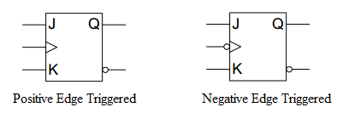
Positive Edge Triggered JK Flip Flop

Circuit Diagram using D-flip Flop and basic gates

Characteristic Table for JK Flip Flop:
Inputs |  | Outputs |  | Next State of Q
J | K | Q | ~Q
0 | 0
0 | 1
1 | 0
1 | 1

T- FLIP FLOP
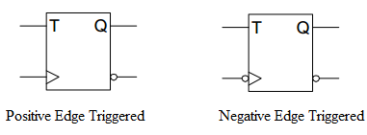
Positive Edge Triggered T-Flip Flop
Circuit Diagram using D-flip Flop and basic gates

Characteristic Table for T Flip Flop:
T | Output
0
1

Negative Edge Triggered JK Flip Flop

Pin Configuration of 74112 (JK-FFP):
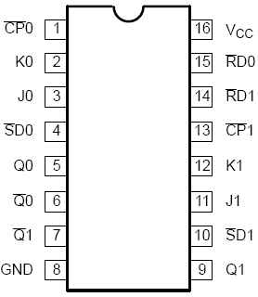

Description of PINS:
The 74F112, Dual Negative Edge-Triggered JK-Type Flip-Flop, feature individual J, K, Clock (CPn), Set (SD) and Reset (RD) inputs, true (Qn) and complementary (~Qn) outputs. The SD and RD inputs, when Low, set or reset the outputs as shown in the Function Table, regardless of the level at the other inputs. A High level on the clock (CPn) input enables the J and K inputs and data will be accepted. The logic levels at the J and K inputs may be allowed to change while the CPn is High and flip-flop will perform according to the Function Table as long as minimum setup and hold times are observed. Output changes are initiated by the High-to-Low transition of the CPn.
Function Table:
INPUTS |  |  |  |  | OUTPUTS |  | OPERATING MODE
SD | RD | CP | J | K | Q | Q
0 | 1 | X | X | X | 1 | 0 | Asynchronous Set
1 | 0 | X | X | X | 0 | 1 | Asynchronous Reset
0 | 0 | X | X | X | 1* | 1* | Undetermined *
1 | 1 | ↓ | 1 | 1 | ~q | q | Toggle
1 | 1 | ↓ | 0 | 1 | 0 | 1 | Load “0” (Reset)
1 | 1 | ↓ | 1 | 0 | 1 | 0 | Load “1” (Set)
1 | 1 | ↓ | 0 | 0 | q | q | Hold “no change”
1 | 1 | 1 | X | X | Q | Q | Hold “no change”

* = Both outputs will be High while both SD and RD are Low, but the output states are unpredictable if SD and RD go High simultaneously

Procedure
- Connect the trainer with the power supply
- Mount the IC 74LS112 on the trainer board
- Supply the VCC and GND to the pin 16 and 8 respectively
- Connect only one of the two flip-flops available on the IC. Refer to the pin configuration and characteristic table (function table) for this IC is given above.
- Drive the J, K and CK inputs input switch on the trainer board and CP input from the clock on the trainer board. Connect output Q0 & ~Q0 with the LED.
- Be sure to connect the set (SD) and reset (RD) inputs to a logical 1.
- Using the different input combinations, verify the JK flip-flop characteristic table.
- Observe and record the output on the LED.

Tasks:
- Implement JK-Flip Flop using D-flip Flop IC and basic Gates on Trainer Board and verify its truth table.
- Modify part (a) to implement T-Flip Flop.
- Verify JK-Flip Flop truth table using 74LS112 IC.
- Modify part (c) to design a T-Flip Flop.

